1. **Install Power BI Desktop and share the final screenshot of the report view page which appears when power desktop starts.**

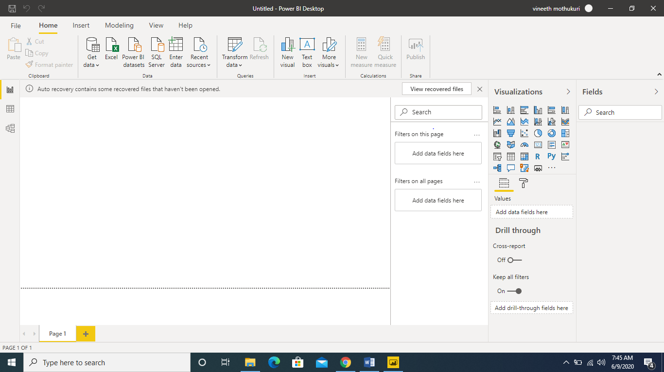

1. **Prepare a document and with the following screenshot**
2. − Report View

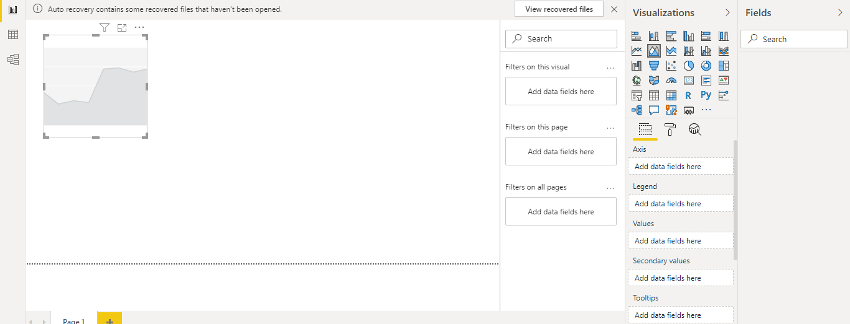

1. Data View

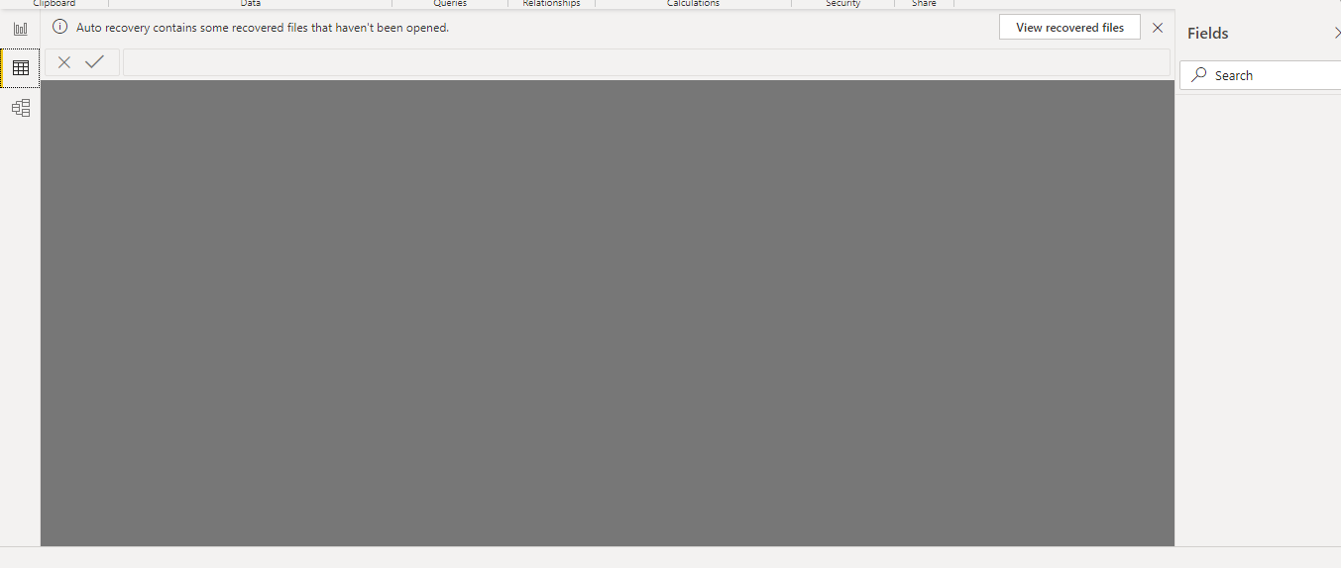

1. Model View

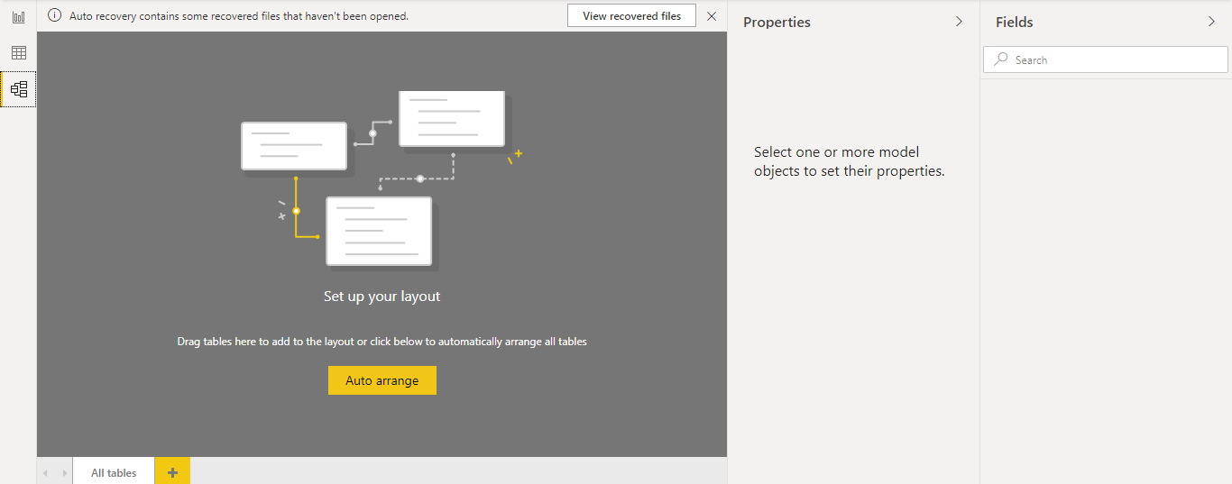

1. Power Query Editor

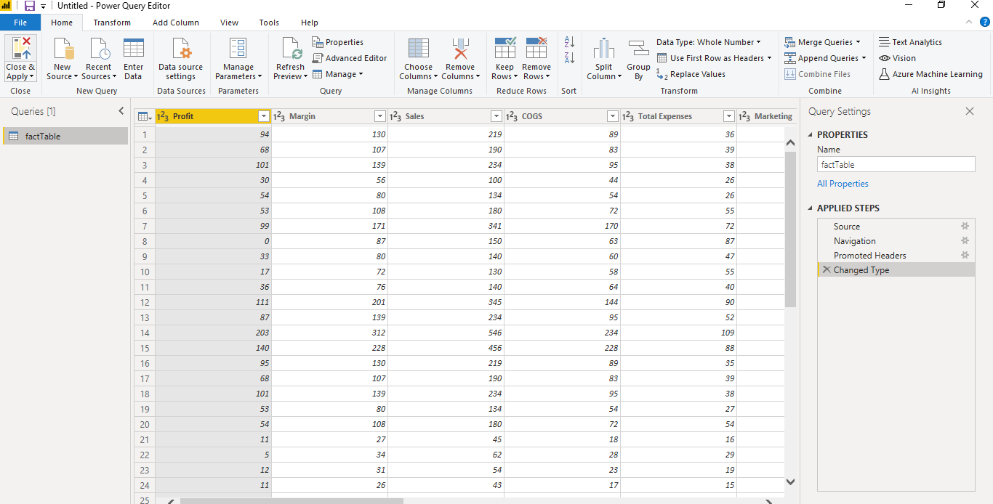

1. Advance Editor

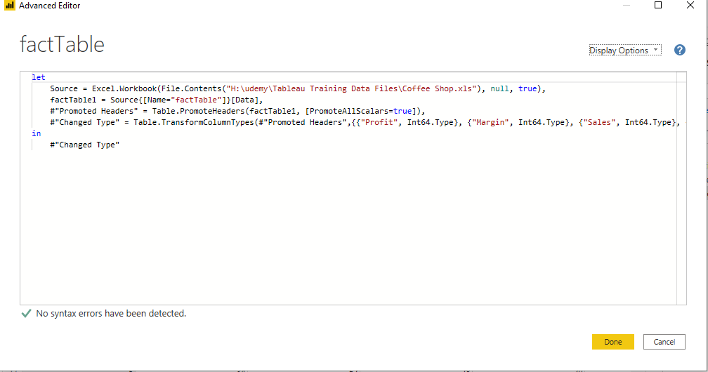

1. **Prepare a document with details of the following along with their price**
2. Power BI Desktop:

It is a **free** application you install on your local computer that lets you connect to, transform, and visualize your data.

**cost: free**

1. Power BI Pro:

It is an individual user license that lets users read and interact with reports and dashboards that others have published to the Power BI service

**cost: $9.99/month**

1. Power BI Premium:

Power BI Premium is a capacity-based offering that includes: Flexibility to publish reports broadly across an enterprise, without requiring recipients to be licensed individually per user.

**Cost: $4,995/month**